T
款
自
动
码
垛
机
电
控
说
明
书
Electric control manual of XXDW-1200 automatic Block Cubing System

目录
第一章：使用前须知
第二章：安装调式
第三章：参数简述
第四章：注意事项
第五章：故障排除
第六章：产品声明
CATALOG
Chapter 1: Notes before use.
Chapter 2: Installation and debugging
Chapter 3: Parameters description
Chapter 4: Attention
Chapter 5: Troubleshooting
Chapter 6: Product statement

第一章：使用前须知
您在使用本机械前，请认真阅读本说明书，如有什么设备异常请及时发现并处理，请以以下各方面入手：
- 在设备的运输过程中是否有损坏。
- 设备的电控系统的安装及保管环境是否良好。
- 电控箱内元器件是否有因在运输途中颠簸而脱落或损坏。
Chapter 1: notes before use.
- Before using the equipment, please read this manual carefully. If there are any abnormal, please find and deal with them in time, please start from the following aspects:
1. Whether there is any damage during the transportation of the equipment.
2. Whether the installation and storage environment of the electronic control system of the equipment is good.
3. Whether the components in the electric control box have fallen off or damaged due to bumps in transit.

第二章：安装调式
- 电控箱垂直正立安装，电控箱以通风易于检查与维修为准。

- 为防止因机械振动而使本机械内的接头松动，请处理安装的减振设备或远离机械的振动源。

- 所有与电控箱相连的电线等请务必开启地槽布线，以便减少因线槽裸露或不正常安装而发生意外。

- 电控箱的外壳一定须有良好的接地，但不能接“零线”。

- 在电源线接入前请先准备一个三相断路器（根据实际功率选择空开），依实际需要选择10mm²或16mm²……的三芯铜电线（以实际功率选），外部电源（3相 AC380V）通过断路器后接到电控箱内的 空开的进线。其他电机线请对着电机线上的号码与电控箱底部线排上号码一一对应接上。

- 电控箱底部线排边有航空插头（具体个数以实物为准），请依各自的标志用随机配的航空插线插上，使之分别与油箱上的控制电磁阀的小箱子和在机械上控制感应器的小箱子相连。

7、完成以上电路连接后，请在检查以下：
    - 所有的连接是否正确且牢固。
    - 电控箱底部线排上有无漏接线未接。
    - 各端子和接线之间是否有短路或对地短路。
    - 接入电源后，若要改变电机方向须对调接线时，请先断开电源后，在进行操作。

Chapter 2: installation and debugging.
1. The electric control box is installed vertically and upright. The electric control box is ventilated and easy to check and maintain.
2. In order to prevent the joints in the machine from loosening due to mechanical vibration, please deal with the installed damping equipment or keep away from the vibration source of the machine.
3. All wires connected to the electric control box, etc., must open the geosyncline wiring in order to reduce accidents due to the exposed or abnormal installation of the wire slot.
4. The shell of the electric control box must be well grounded, but it cannot be connected to the "zero wire".
5. Before the power line is connected, please prepare a three-phase circuit breaker (choose empty according to the actual power), and choose 10mm ²or 16mm2 according to the actual needs.
The three-core copper wire (selected by actual power), and the external power supply (3-phase AC380V) is connected to the empty incoming wire in the electric control box after passing through the circuit breaker.
For other motor lines, please connect the number on the motor line to the number on the bottom line of the electric control box one by one.
6. There are aviation plugs on the bottom line of the electric control box (the specific number is subject to the physical object). Please plug in the aviation plug randomly according to their respective signs, so that it is connected to the small box on the fuel tank that controls the solenoid valve and the small box that controls the inductor mechanically.
7. After completing the above circuit connection, please check the following:
a. Whether all connections are correct and secure.
b. Whether there is a missing connection at the bottom of the electric control box.
c. Whether there is a short circuit or ground short circuit between the terminals and the wiring.
d. After connecting to the power supply, if you want to change the direction of the motor and need to adjust the wiring, please disconnect the power supply first and then operate.

注意：
- 勿让金属碎块.各种纤维等导电与易燃异物进入电控箱内或其他主要控制部件上。
- 必须良好接地。
- 配线作业须有专业熟悉人员来进行。
- 确认电源断开后开始作业维修。

Note:
1. Do not let metal fragments, various fibers and other conductive and combustible materials enter the electronic control box or other major control components.
2. Must be well grounded.
3. The wiring operation must be carried out by professional and familiar personnel.
4. Start maintenance after confirming that the power supply is disconnected.

第三章：参数简述
Chapter 3: Parameters description

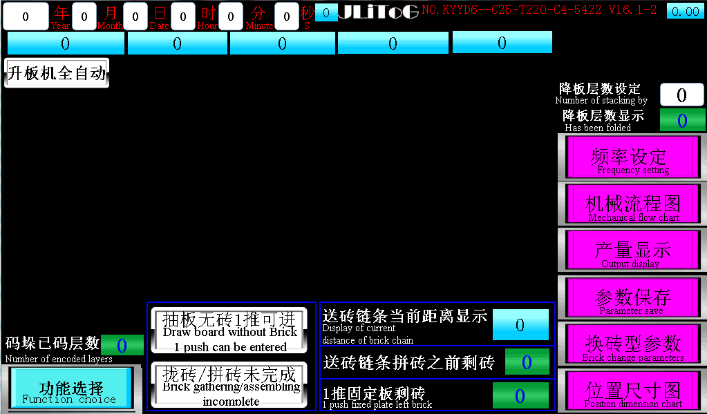

以上画面为刚上电时的页面（首页）
The above screen is the page at the time of power-on (home page)
- 抽板无砖1推可进：此键由白色自动转为红色时，表明检测到抽板处有砖，已具备码砖的条件。当操作台上的按键处于“自动”状态下，砖自动往码垛方向前进。

- 拢砖未完成：此键自动变成红色之后，表明一推底下有砖，打自动一推会直接前进。

3.机械流程图：点开之后，可以看到整个设备工作的流程。

1.Draw board without Brick, 1 push can be entered: when this key changes from white to red automatically, it indicates that there are bricks at the extraction board (draw board) and has the condition of gathering bricks. When the keys on the console are in the "auto" state, the bricks automatically move towards the palletizing direction.
2. Brick gathering/assembling incomplete: When the key automatically turns red, it indicates that there are bricks at the bottom of the 1 push, and the 1 push will move forward directly in condition of “ auto” state.
3. Mechanical flow chart: after clicking on, you can see the work flow of the whole equipment.
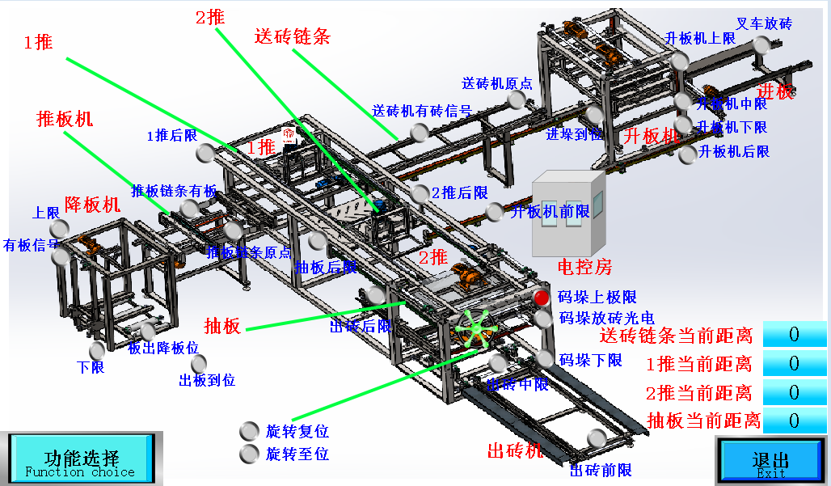
- 产量显示：点开之后，可以看到每天的工作产量。
- Output display: Click on it, you can see the daily output.

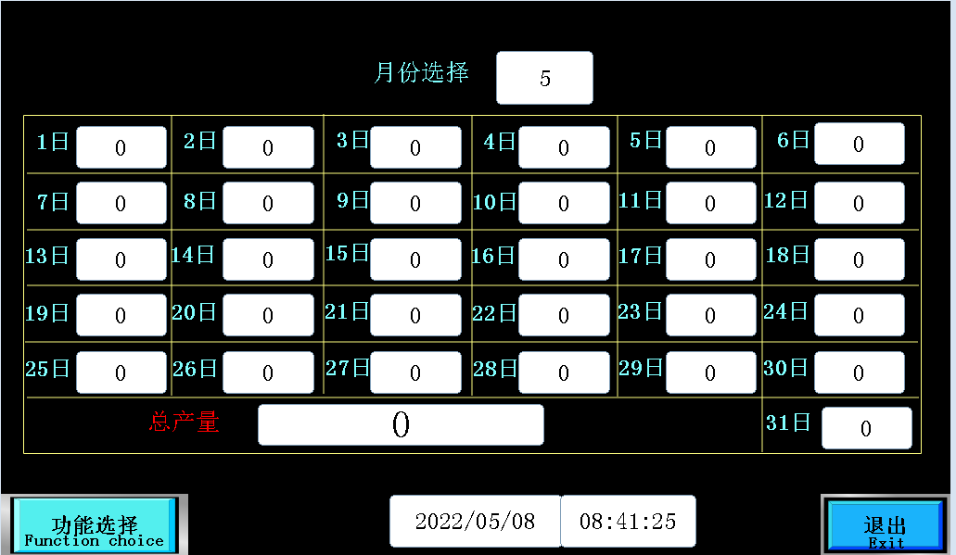

- 参数保存：点开之后，可以把现用的参数存下来，等下次再收这个砖的时候，就不需要重新设置参数，直接点调用。
2. Parameter save:Click on it, you can save the current parameters, and the next time you need to collect the same type of brick, you do not need to reset the parameters, just click on the” call” button is OK.
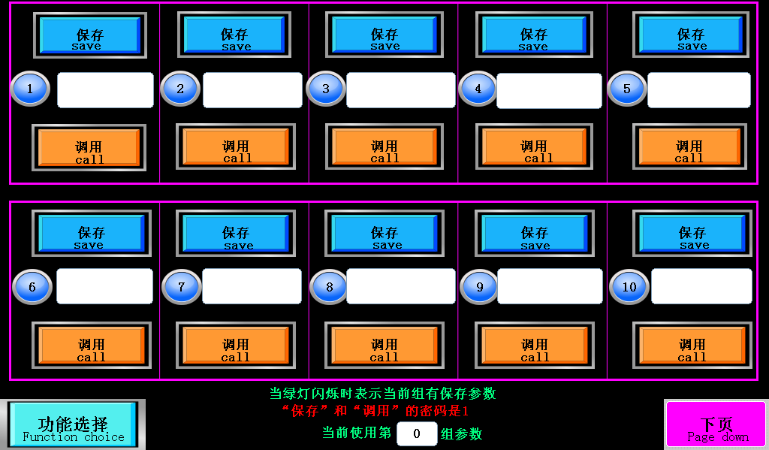
- 换砖型参数：换砖的时候，只需要点开这里，把里面的参数调好就可以直接自动。
3.Brick changes parameters: When you need to change the shape of the brick, click here and adjust the corresponding parameters as showed following that’s OK.

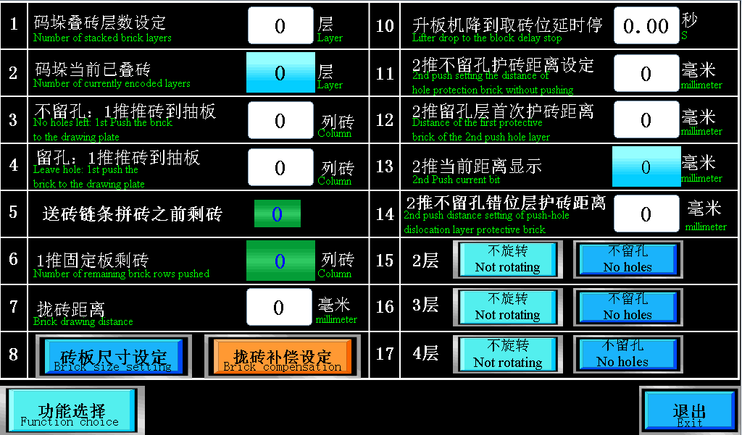

- 位置尺寸图：点开之后，可以清楚看到自己都设了哪些距离参数。
4.Position dimension chart: Click on it, you can clearly see what distance parameters you have set.
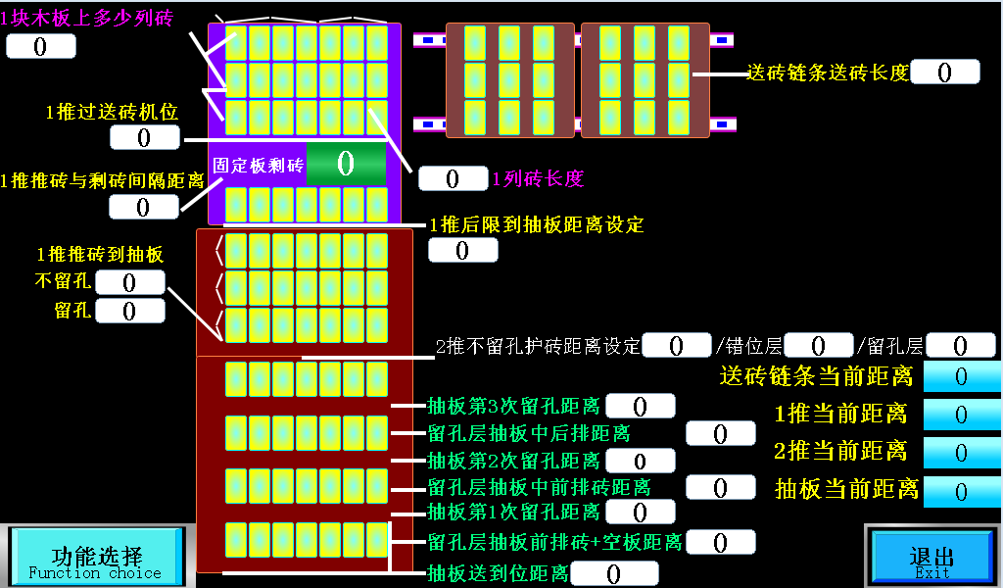
- 频率设定
5.Frequency setting

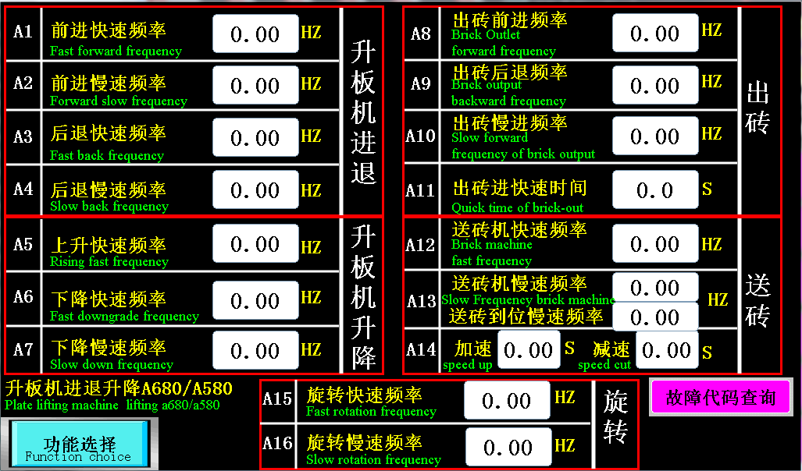
第三章：参数简述
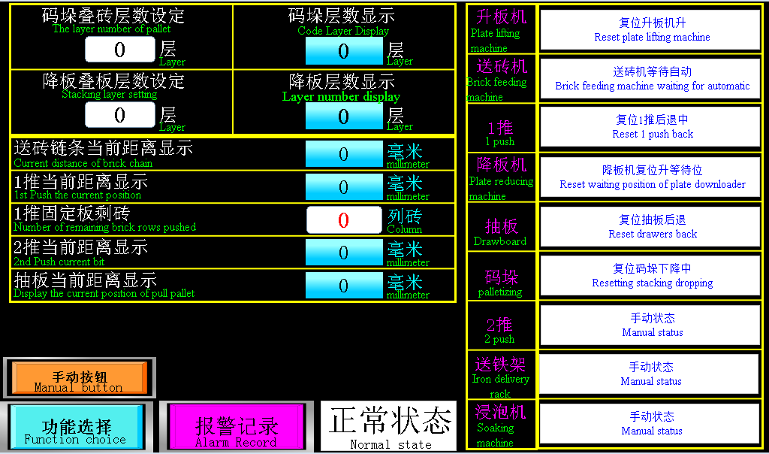
以上页面为状态显示
- 码垛叠砖层数：指一垛砖需要码几层。

- 降板机叠板层数：指降板机那边需要收多少层板。

- 一推固定板剩砖：指一推前面那块不会动的铁板，上面还有多少排砖。

注：距离显示指：各个伺服走了多远出去（不可调）

注：右边为各个机构的运行状态（打自动字会随着下一步动作而改变）

The above page is the” status” display.
1. The layer number of pallet: For setting how many layers bricks are needed for a bundle.
2. Stacking layer setting: refers to how many layers pallets can be collected by the lower-board machine at a time.
3. Number of remaining brick rows push : refers to how many rows of bricks there are on the immovable iron plate in front of 1st push.

Note1: 2nd push current bit and Display the current position of pull pallet, these two distance shows how far each servo has gone (non-adjustable).
Note2: the running status of each organization is on the right (numerical value will change automatically with the next action)
第三章：参数简述

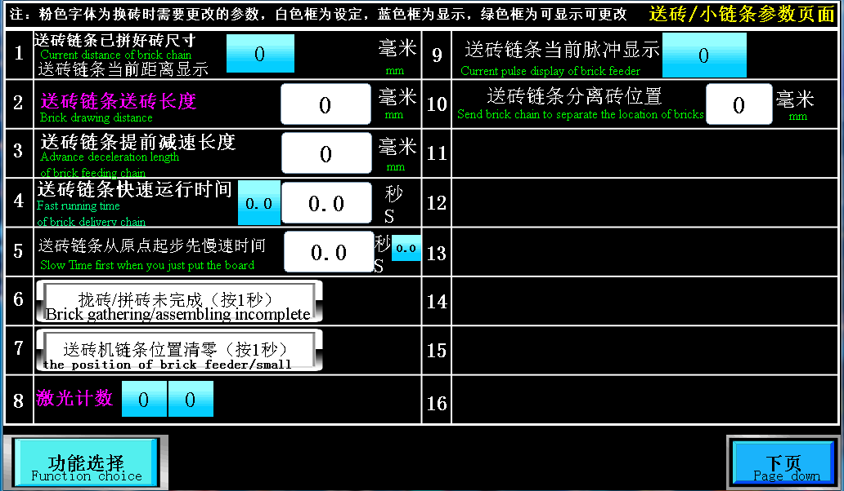
以上页面为伺服设定
- 送砖链条当前距离显示：显示当前送砖链条砖已经送的长度

- 送砖链条送砖长度：指拢砖需要的长度，如一块砖240，需要4块砖，距离就是960。但是电机有惯性，正常提前15-20毫米停，所以设定940左右就可以

- 送砖链条提前减速：指拢砖距离剩下多少之后开始走慢速。

- 送砖链条快速运行时间：指送砖机快速走多久之后，开始走慢速。

- 板刚放不下来先慢时间：指升板机板放下来走多久慢速，再走快速。

- 送砖机位置清零：按一秒会把送砖长度距离清零。

- 送砖链条分离砖位置：送砖需要快拼完砖时气缸夹住后面的砖，防止后面的砖被1推

The above page is set for servo motor.
1. Display the current distance of the brick chain: show the length of the brick chain that has been sent.
2.Brick drawing distance: the length required to gather the bricks, such as 240mm for a brick, requires 4 bricks, and the distance is 960mm. But the motor has inertia, which normally stops 15-20 mm ahead of schedule, so you can set it to about 940.
3. Advance deceleration length of brick feeding chain: it begins to walk slowly after the distance set left between the bricks.
4.Fast running time of delivery chain: how long after the brick feeder walks fast, it begins to walk slowly.
5. Slow Time first when you just put the board: For setting how long time runs slowly when the lift board just feed the pallet, and then go fast.
6. The position of brick feeder: press and hold on one second to clear the length and distance of the brick.
7, Send brick chain to separate the location of bricks: when the brick delivery almost finished, clamp the back brick with cylinder to prevent them from being pushed by 1.
第三章：参数简述
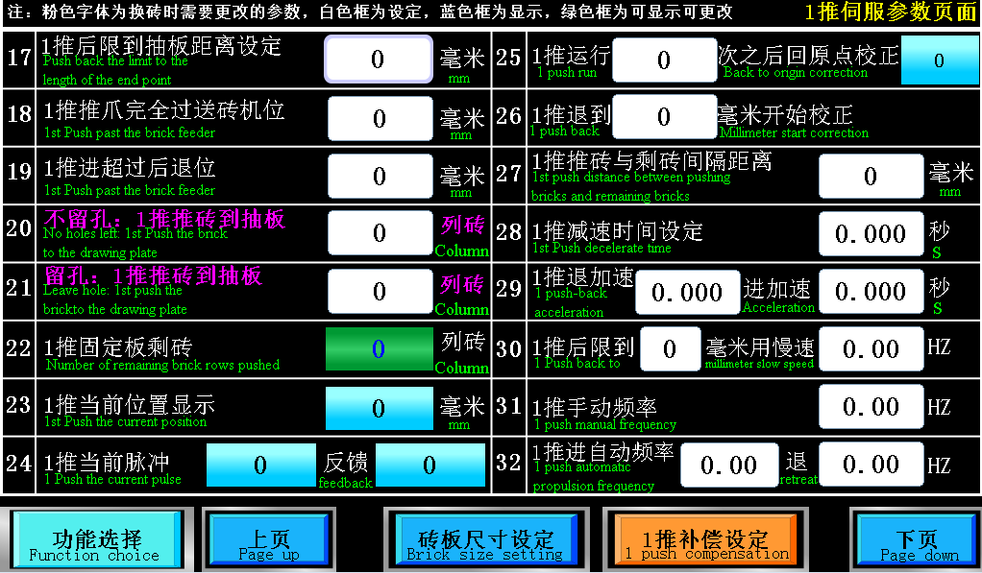
以上页面为伺服设定
- 一推后限到抽板距离：指一推后限到抽板边缘的总行程。

- 一推过送砖机位：指一推往前走多远之后，送砖机可以继续送砖。

- 1推进超过后退位：指1推推爪前面部分过送砖链条此位置时剩砖如何不够1层，1推就可以直接退回去

- 不留孔一推推砖到抽板：指不留孔码一层需要多少列砖。

- 留孔一推推砖到抽板：指留孔码一层需要多少列砖（一定比不留孔列数少）。

- 一推固定板剩砖：指一推前面那块不会动的铁板剩多少列砖。

- 一推伺服运行多少次回原点校正：指一推自动走多少次回原点校正。
- 一推自动退到多少毫米回原点：指一推自动退到什么位置开始校正。
- 一推推砖与剩砖之间间隔：指一推把砖推过来之后，与前面的砖隔多久等待抽板回来。

- 一推后限到多少毫米慢速：指一推刚起步时，先走多少慢速再快速。

The above page is set for servo.
1. Push back the limit to the length of the end point: refers to the total stroke from 1 push back limit to the edge of the drawing board.
2. 1st push past the brick feeder : refers to how far the brick feeder can continue to send bricks after a push.
3. 1 push over backward position: refers to when the front part of the push claw passes through this position of the brick chain, if the remaining bricks are not enough to stack 1 layer, 1 push can be pushed back directly.
4. No holes left: 1st push the brick to the drawing plate: it refers to how many rows of bricks are needed for a layer without preforming forklift holes.
5. Leave hole: 1st push the brick to the drawing plate: it refers to how many rows of bricks are needed for each layer with preforming forklift holes (it must be less than without holes).
6. Number of remaining brick rows pushed: refers to how many rows of bricks are left in front of the immovable iron plate.
7. 1 push run back to original correction: refers to how many times the 1st push runs then goes back automatically to the origin correction.
8. 1 push back () millimeter start correction: refers to the correction begins when 1st push automatically retreats to the position of a specified distance.
9. 1st push distance between pushing bricks and remaining bricks: refers to how long it takes to wait for the drawing board to come back from the previous bricks pushed.
10. 1st push back to () millimeter slow speed: refers to 1st push just started, how long to walk slowly first and then run fast.
第三章：参数简述

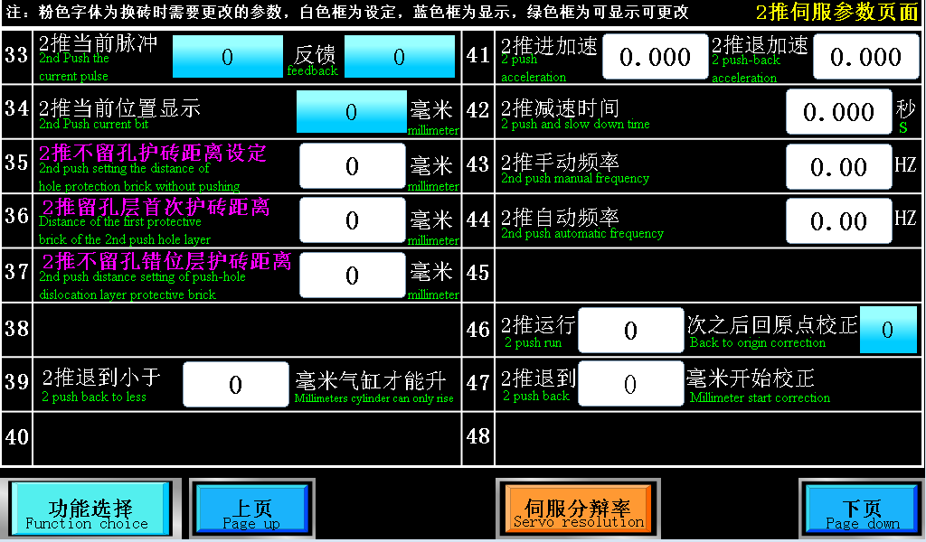
以上页面为伺服设定
1、2推不留孔距离设定：指不留孔时，二推往前走多少，可以把砖推到托盘中间。

2、2推留孔护砖距离：指留孔时，二推往前走多少，可以把砖推到托盘中间。

3、2推不留孔错位层距离设定：指二推跟正常层错位距离，如正常层走500，你想错开10毫米，就设置510

5、2推退到小于多少毫米气缸才能升：指二推往后退多远，气缸才能升，保证不撞到码垛

6、2推伺服运行多少次回原点校正：指二推自动走多少次回原点校正。

7、2推自动退到多少毫米回原点：指二推自动退到什么位置开始校正。
The above page is set for servo.
1, 2 push setting the distance of hole potection brick without pushing: It means without preformed holes, the 2nd push forward how long, it can push bricks to the middle of the tray.
2,Distance of the first protective brick of the 2nd push hole layer: When there is a reserved forklift holes, when the second push forward how many millimeters, the brick can be pushed to the middle of the tray.
3.2nd push distance setting of push-hole dislocation layer protective brick: refers to the dislocation distance between the second push and the normal layer. If the normal layer goes 500, if you want to stagger 10 mm, set 510.
5. 2nd push back to less ()millimeter cyliner can only rise: refers to the second push back how far before the cylinder can be raised to ensure that it does not hit the palletizing.
6. 2nd push run ()times back to origin correction: refers to how many times the 2nd push walkds then goes back automatically to the origin correction.
7. 2 push back() millimeters start correction: refers to the second push back how far before the cylinder can be raised to ensure that it does not hit the palletizing.
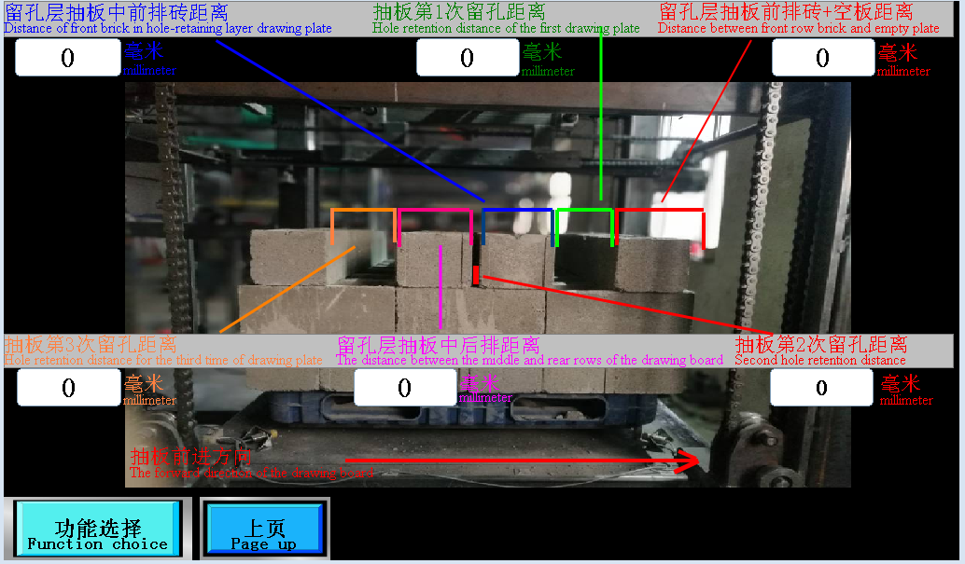

1.留孔层抽板前排砖+空板距离：留孔层第一次抽板在前限往后抽的距离，如留孔层前排标砖厚度是50毫米需要3块，那就是150毫米+抽板前面空的距离

2.抽板第1次距离：抽板第1个叉车孔的距离,正常设130-150之间

3:留孔层抽板中前排砖距离:如标砖留中间的需要7块那就是350,

4.抽板第2次留孔距离:如需留3个孔时,此参数可以设定1个小孔,如路面砖100X200的时候可能需要用这个小孔来错位上下层的砖

5.留孔层抽板中后排距离:此参数配合上一个参数使用,使砖上下层错位

6.抽板第3次留孔距离: 抽板留第2个叉车孔位置,正常设130-150之间

1. Distance of front brick in hole-retaining layer drawing plate: the first time the hole layer draws the plate in the front limit, if the thickness of the front row standard brick in the hole layer is 50 mm, you need 3 pieces, that is 150 mm + the distance in front of the extraction board.
2. Hole retention distance of the first drawing plate: the distance of the first forklift hole of the drawing plate, normally set between 130 and 150.
3: Distance between front row brick and empty plate: if the standard brick needs 7 pieces in the middle, that is 350.
4.Second hole retention distance: if you need to leave 3 holes, this parameter can set 1 small hole, such as road brick 100X200, you may need to use this small hole to stagger the upper and lower layers of bricks.
5. The distance between the middle and rear rows of the drawing board: this parameter is used with the previous parameter to make the upper and lower layers of the brick stagger.
6. Hole retention distance for the third time of drawing plate: leave the second forklift hole position, the normal setting is between 130 and 150
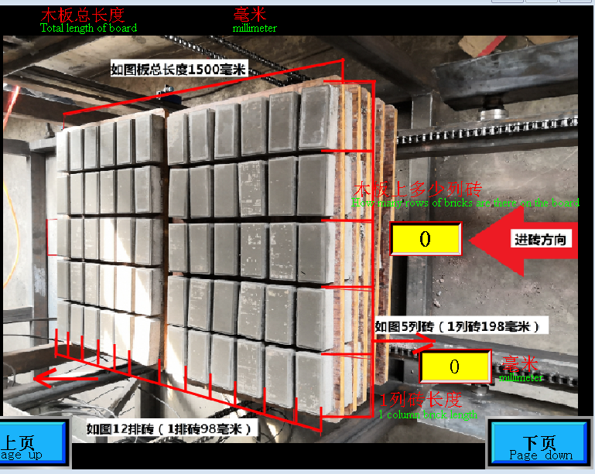

木板上多少列砖:1推每次从后限补的砖列数,(1推往抽板的方向的砖列数)
1列砖长度: 1推往抽板的方向的每块砖厚度
How many rows of bricks are there on the board:How many rows of bricks the first push adds from the rear limit each time, (the number of rows of bricks first push in the direction of the drawing board).
1 column brick length: the thickness of each brick in the direction of the first push drawing board
第三章：参数简述
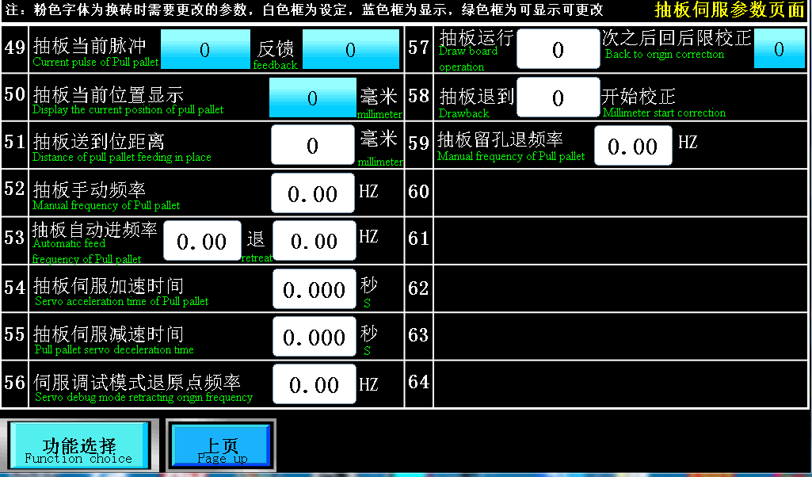
以上页面为伺服设定
- 抽板送到位距离：指抽板往前走多少，二推挡板降下来不会压到砖。

2、抽板伺服运行多少次回原点校正：指抽板自动走多少次回原点校正。

3、抽板自动退到多少毫米回原点：指抽板自动退到什么位置开始校正。

4．抽板伺服加速时间：抽板进退时起步加速的时间

5．抽板伺服减速时间：抽板进退时起步减速的时间

6伺服调试模式原点频率：1推，2推，抽板伺服用调试进退时的速度

7抽板手动频率： 抽板手动进退时的速度

8抽板自动进频率：抽板自动进退时的速度

9.抽板留孔退频率：留孔时抽板后退的速度，标砖时速度需设小

1. Distance of pull pallet feeding in place: it refers to how many millimeters the drawing board goes forward, and the second push baffle will not be pressed to the brick.
2. Draw back ()millimeter start correction: it refers to the automatic return to the origin correction after how many times the drawing board works.
3. How many millimeters back to the origin of the drawing board automatically: it means that the drawing board automatically retreats to the set distance and begins to correct.
4. The acceleration time of the servo motor: the starting acceleration time when the board is pulled in and out.
5. Deceleration time of drawing board servo motor: the time of starting deceleration when drawing board forward and backward.
6 Servo debugging mode origin frequency: 1 push, 2 push, pull board servo debugging speed.
7 manual frequency of drawing board: the speed of manual advance and retreat of drawing board.
8 automatic advance frequency of drawing board: the speed of automatic advance and retreat of drawing board.
9.
Withdrawal frequency when there is a hole in the drawing board: the speed at which the board retreats when the hole is retained, and the speed should be set to a small value when used as a standard brick.
第三章：参数简述
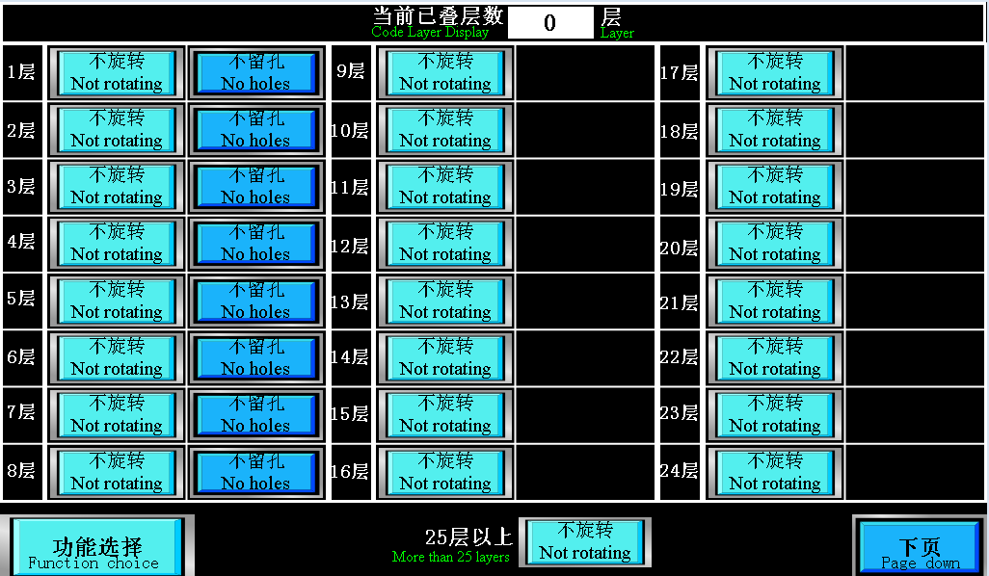

以上页面为旋转与留孔
- 哪一层需要旋转，点击一下即可。
以下页面为错位选择
- 哪一层需要错位，点击一下即可。
The above pages are for rotation and hole retention.
1. Which floor needs to be rotated or reserved fork hole, click the button on the corresponding layer.
The following pages are selected for cross bits.
2. Which floor needs to be crossed, just click the corresponding layer button.

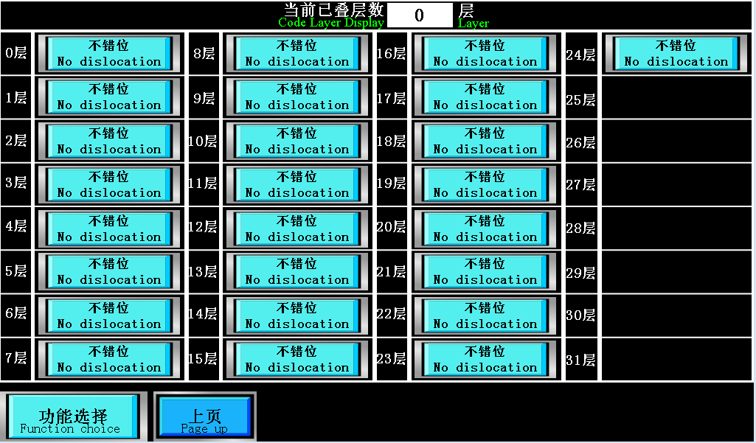
第三章：参数简述

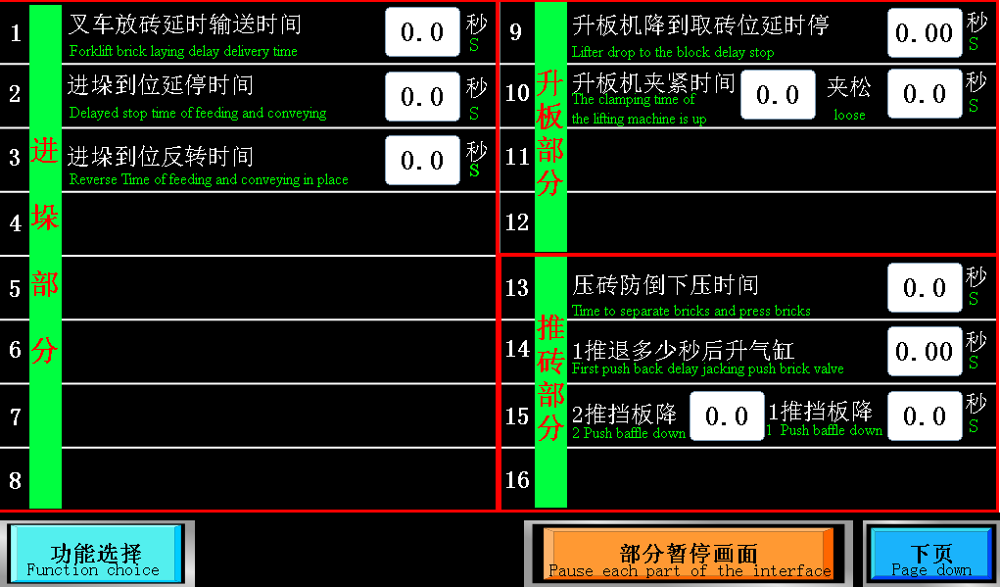

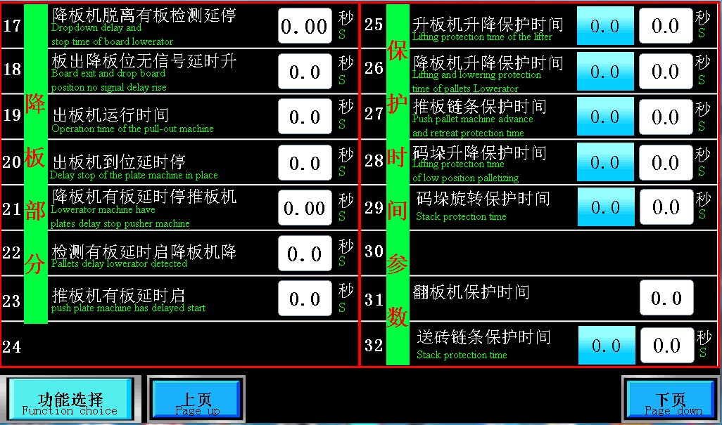

以上页面为参数设定
- 叉车放砖延时输送时间：指叉车放好砖之后等多久链条开始启动。
- 上料输送到位延停：指链条把砖送到位之后等多久再停链条。
- 上料输送到位反转时间：指砖送到位之后，再反转多久时间。
- 升板机降到取砖位延时停：指升板机光电照到砖之后，再下降多久可以取到砖。
- 升板机夹紧和松开时间：指升板机夹多久，夹子可以夹到到板，松开同理。
1. Forklift brick laying delay delivery time: it means after the forklift truck has placed the brick, wait for how many seconds before the chain starts to start.
2. Delay time of feeding and conveying: refers to the chain after the brick is in place, wait for how many seconds before stopping the chain.
3. Reverse time of feeding and conveying in place: it refers to how long it will take after the bricks are sent into place.
4. Lifter drop to the block delay stop: it refers to how many seconds after the photoelectric illumination of the lift machine reaches the brick, the brick can be obtained.
5.he clamping time of the lifting machine is up () loose () second: refers to how long the lifting machine clamps, and the claws can be clamped to the board and loosened in the same way.
- 升板机保护时间：指升板机下限到上限需要多久时间，超过这个时间，升板机停止工作。
- 压砖防倒下压时间：指压砖阀，工作多久时间，可以压到砖。抽板就前进
- 1推退多少秒升气缸：指一推先退多久，再升气缸，如果直接升气缸，会把砖带倒。
- 2推和1推挡板下降：指1推和2推，挡板下降多久时间，1推和2推可以前进。
- 降板机脱离有板检测延时停：指降板机有板信号不亮了之后，再往下降多久时间再停。
6.Lifting protection tie of the lifter: refers to how long it will take from the lower limit to the upper limit of the lift. Beyond this time, the lift will stop working.
7.Time to separate bricks and press bricks: refers to the pressure brick valve has to work how long, it can press to the brick. Draw board will move forward.
8. First push back delay jacking push brick valve: refers to 1 push back how many seconds, and then lift the cylinder. If lift the cylinder directly, it will bring the brick down.
9. 2 push baffle down () 1 push baffle down(): refers to 1 push and 2 push, how long the baffle falls, 1 push and 2 push can move forward.
10. Dropdown delay and stop time of board lowerator: it refers to how long it will take to drop again after the board signal of the falling machine is not lit

- 板出降板位无信号延时升：指板出去降板机之后，再等多久升降板机。
- 出板机运行时间：指出板机工作多久时间停。
- 出板机到位延时停：指出板机到末端了之后，再等多久停链条。
- 降板机有板延时停推板机：降板机感应器到有板信号之后，再等多久停推板机。
- 检测有板延时启降板机：指降板机有板信号亮多久之后，降板机再往下降。
- 推板机有板延时启：指推板机上，有板信号亮多久之后，再启动推板机。
- 降板机保护时间：指降板机从上限到下限用多久时间，超过这个时间，降板机停止工作。
- 推板链条保护时间：指推板机转一圈需要多久时间超过这个时间，推板机停止工作。
19, 翻板机保护时间: 指翻板机转一圈需要多久时间超过这个时间，翻板机停止工作。
- 送砖链条保护时间：指送砖链条机转一圈需要多久时间超过这个时间，送砖链条停止工作
11.Board exit anddrop board position no signal delay rise: after pallet(board) is output from lowerator, how long will the lowerator has to wait to rise again.
12. Operation time of the plull-out machine: refers to how long the output pallet device will work.
13. Delay stop of the plate machine in place: indicate how long the chain will stop working after the output feeder device reaches the end.

14. Lowerator machine have plates delay stop pusher machine: after the sensor of the lowerator detects the signal of the board, how long will it wait for? then the pushing machine to stop working.
15. Pallets delay lowerator detected: refers to how long after the board signal light is on, the lowerator goes down again.
16. Push plate machine has delayed start: it refers to how long after the board signal is on, and then start the push machine again.
17.Lifting and lowering protection time of pallets lwerator: refers to how long it takes from the upper limit to the lower limit. Beyond this time, the lowerator stops working.
18.Push pallet machine advance and retreat protection time: refers to how long it takes for the push board device to turn around, beyond this time, the push board machine stops working.
19. the protection time of the turnover pallet device: refers to how long it takes for the turning machine to turn around. Beyond this time, the turning machine stops working.
20.Stack protection time: refers to how long it takes for the brick chain machine to turn around, beyond this time, and the brick chain stops working
第三章：参数简述

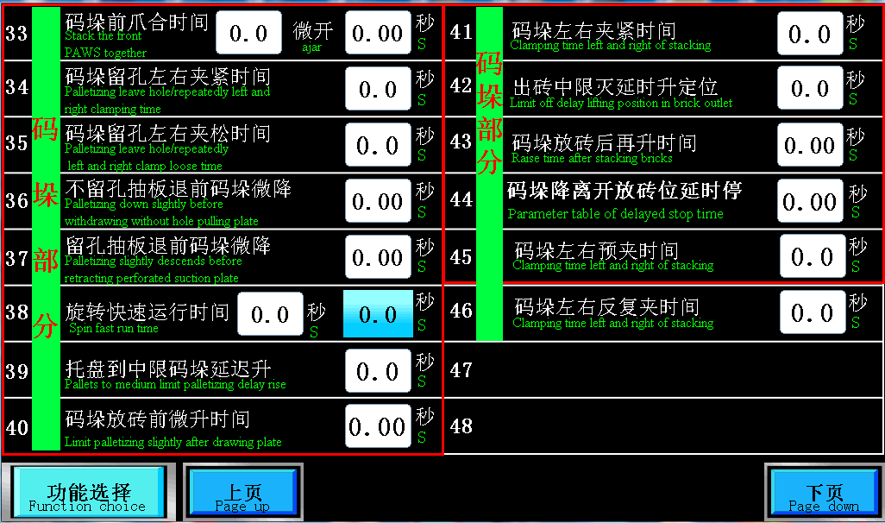
以上页面为参数设定
- 码垛前爪开合时间：指码垛前爪运行多久时间，前爪可以顶到砖。
- 码垛留孔反复夹紧时间：指码垛留孔时，左右夹夹多久时间，抽板再往后退。
- 码垛留孔反复夹松时间：指码垛留孔时，左右夹松多久时间，抽板再往后退。
- 不留孔抽板退前码垛微降：指抽板准备退的时候，码垛下降多久，抽板再退。
- 留孔抽板退前码垛微降：指抽板准备退的时候，码垛下降多久，抽板再退。
- 旋转快速运行时间：指码垛转盘快速走多久，开始走慢速。
- 托盘到中限码垛延时升：指空托盘走到中限后，再等多久升码垛。
- 抽板退后限码垛微升：指抽板退后限之后，码垛微升多久，能接到砖。
- 码垛放砖后再升时间：指码垛接到砖之后，左右先不夹，再升多久，才夹。
- 码垛左右夹紧时间：指码垛左右夹，夹多久才能把砖夹紧。
- 出砖中限灭延时升定位：指出砖中限灭后，再等多久升定位气缸，把后面的托盘顶住。

12.码垛降离开放砖位延时停：码垛接到砖下降到光电不亮时再降此时间后旋转
13码垛左右夹时间：码垛不留孔时左右夹的时间
- 码垛左右反复夹时间：码垛接完砖后码垛左右再夹一次砖时间

1.Stack the front PAWS together() ajar(): refers to how long the palletizing front claw runs, and the front claw can be pushed to the brick.
2. Palletizing leave hole/repeatedly left and right claming time: when the palletizing retaining hole, how long the left and right clamping time is, and then pull the board back.
3. Palletizing leave hole/repeateldly left and right clamp loose time: when the palletizing retaining hole, how long the left and right clamps are loosened, and then pull the board back.

4.Palletizing down slightly before withdrawing without hole pulling plate: when the drawing board is ready to retreat, how long the palletizing falls, and then back off.

5.Palletizing slightly descends before retracing perforated suction plate: it refers to how long the palletizing falls when the drawing board is ready to withdraw, and then back off.

6.Spin fast run time: refers to how long the palletizing turntable walks fast, and then begins to walk slowly.

7.Pallets to medium limit palletizing delay rise: refers to the empty pallets go to the mid-limit, how long to wait then the palletizing to rise.

8. Limit palletizing slightly after drawingplate: refers to how long the palletizing micro-rise can receive the brick after the drawing board retreats the back limit.

9.Raise time after stacking bricks: after the stacks are connected to the bricks, the left and right clips will not hold the bricks first, and then how long will it take before they begin to clamp.

10.Clamping time left and right of stacking: refers to the left and right clamps of the palletizing, how long will it take to clamp the bricks?

11.Limit off delay lifting position in brick outlet: how long to wait for the positioning cylinder to rise after the brick middle limit light is off, and hold up the tray behind.

12.Parameter table of delayed stop time: the palletizing rotates after the brick falls to the time when the photoelectric light is not bright.

13Clamping time left and right of stacking: when there is no hole in the palletizing, the time it takes for the left and right clips to clamp the brick.

14.Clamping time left and right of stacking: after the palletizing receives the bricks, the time required for the left and right clips of the palletizing to clamp the bricks.
第三章：参数简述

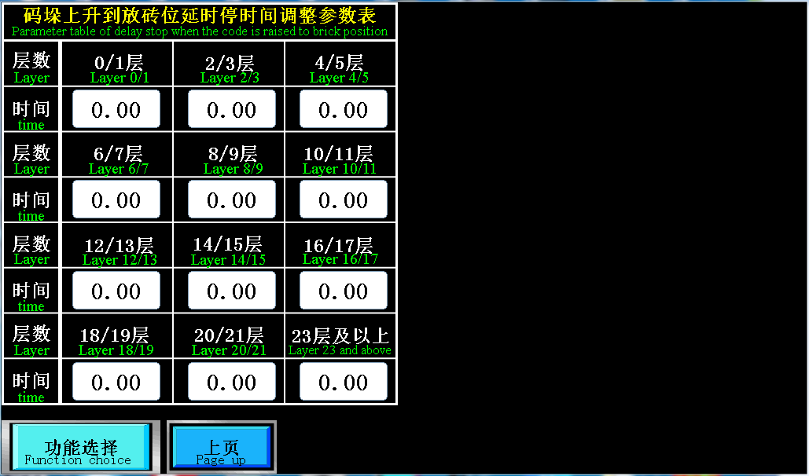
以上页面为参数设定
- 码垛上升延时停时间：指码垛上升照到光电后，再上升多久时间。两层一个时间
1. Palletizing rising delay stop time: refers to how long it takes after the palletizing rises to photovoltaic light. Each two layers take the same time.
动作选择
以下为设备需要时启用各种选择功能
Action selection.
The following enables various selection functions when the device needs it
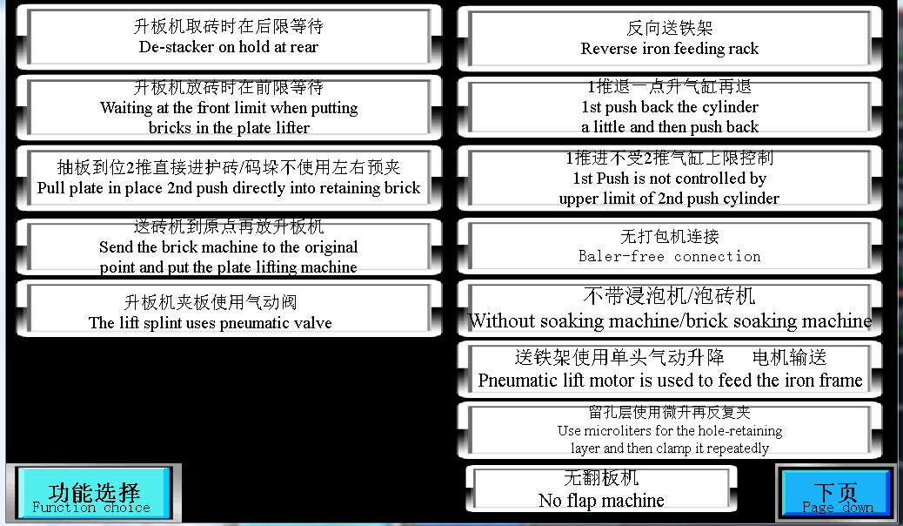
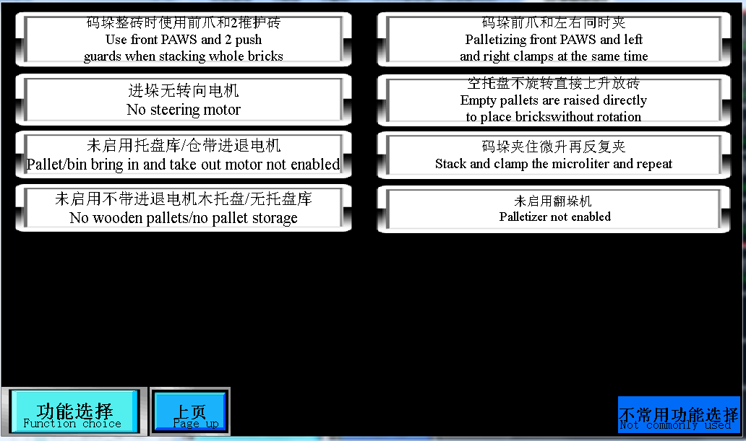

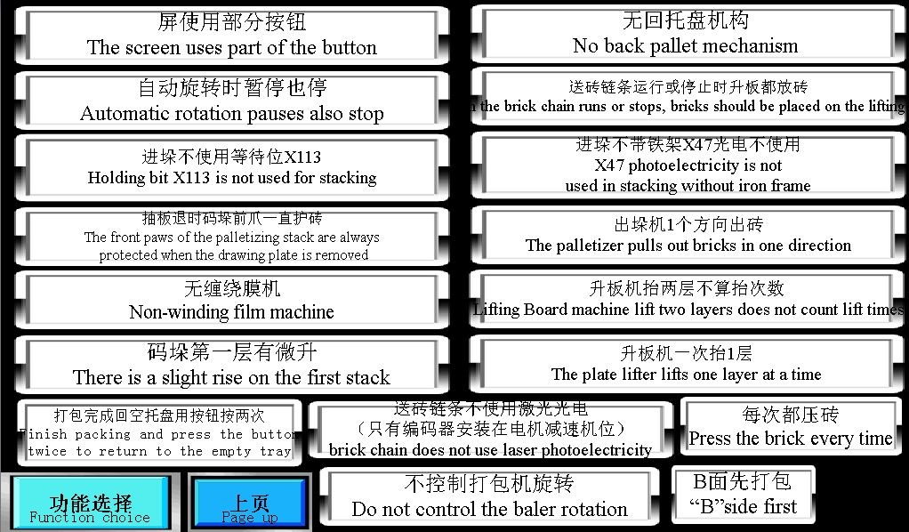

外部激光安装注意点

如下图，
1：激光光电离1推推爪10毫米左右，

2：固定时照砖的斜向上照砖的上半部分，只要照砖的第二块距离位置，不要把所有砖都照到，这样里面的砖如果位置有错位就不能影响到距离，或者不斜照时，只是平照砖时可以把激光距离调短，调到也是照到第二块砖位置也可以（注：这一点很重要，）

3：编码器与激光在尽量在同一个平行线上，前后差一点没关系

4：激光不能跟太阳对照，不然信号会丢失，会照成多送砖，如果有太阳时可以把激光拿个东西遮挡盖一下，防止跟太阳直接对照
Attention points for external laser installation.
The figure below is as follows.
1: laser photoelectric distance 1 push claw about 10 mm.
2: when fixed, the laser shines oblique upward on the upper part of the brick, only need to shine on the position of the second brick from the first brick, and do not take all the bricks. In this way, if the position of the brick inside is misplaced, it will not affect the distance, or when the brick is not oblique, you can adjust the laser distance to the position of the second brick.
3: the encoder and the laser are on the same parallel line as far as possible, and it doesn't matter if you are close to the front and back.
4: the laser can not be directed to the sun, otherwise the signal will be lost and more bricks will be sent. If there is a sun, you can take something to block the laser to prevent it from being directly compared with the sun.
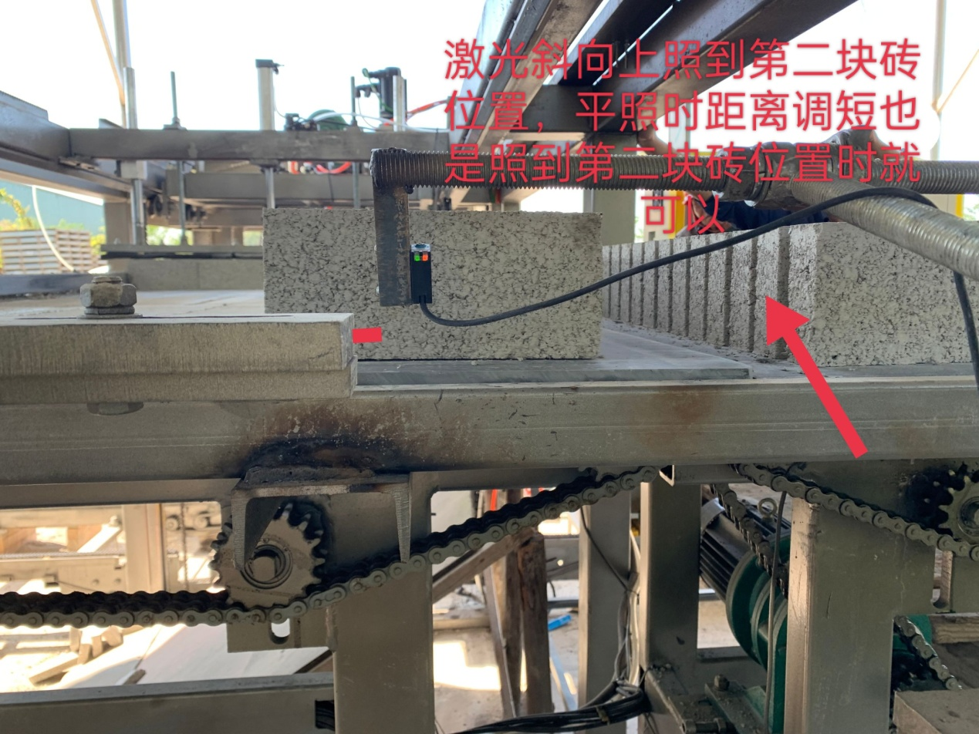
第四章：注意事项

1、严禁非操作人员使用机器。
2、严禁在无良好接地的情况下使用机器。
3、控制系统由强电和弱电组成，出厂时用不同的颜色和线码区分，安装检修时请注意区分，以免弄错，造成机器不必要的损坏。
4、在检修或清扫时必须切断电源。
5、新安装的机台，由于运输中震动有可能造成线路脱落，必须仔细检查，如有脱落或损坏应处理好方可接上电源。
6、应经常检查各外部开关是否良好。
7、各电机都装有热继电器以保护电机，热继电器电流调整值应和电机功率相一致，不能调得太高，以免造成电机烧毁。8、触摸屏应用手指头轻轻触摸，禁止用尖锐物触摸。
9、如遇变频器或伺服报警，应及时拍照下来与厂家联系，以免造成不必要的硬件损坏。
10、如遇跳闸，短路，线路接触不良，漏电，禁止私自处理，应及时与厂家联系，以免造成不必要的人身危险。
Chapter 4: matters needing attention.
1. Non-operators are strictly prohibited from using the machine.
2. It is strictly forbidden to use the machine without good grounding.
3. The control system is composed of strong electricity and weak electricity, which is distinguished by different colors and wire codes when leaving the factory. Please pay attention to the distinction during installation and maintenance, so as not to make mistakes and cause unnecessary damage to the machine.
4. The power must be cut off when overhauling or cleaning.
5. For the newly installed machine, the circuit may fall off due to vibration in transportation, so it must be carefully checked and dealt with if it is fallen off or damaged before it can be connected to the power supply.
6. Always check whether the external switches are in good condition.
7. Each motor is equipped with a thermal relay to protect the motor. The current adjustment value of the thermal relay should be consistent with the motor power and should not be set too high so as not to cause the motor to burn out.
8. The touch screen can only be touched gently with fingers, and it is forbidden to touch with sharp objects.
9. In case of frequency converter or servo alarm, you should take pictures and contact the manufacturer in time to avoid unnecessary hardware damage.
10. in case of tripping, short circuit, bad line contact and leakage, it is forbidden to deal with it privately, and you should contact the manufacturer in time to avoid unnecessary personal danger.

第五章：故障排除
如升板机不会下降
第一步：打开调式状态，按住按钮降，如果能下降，说明在正常状态下，有条件把他互锁住了，可切回正常状态，按住按钮降，触摸屏会弹出报警，哪些动作没到位，不允许下降。

第二步：如果打开调式状态也不能下降，点开触摸屏输出监控，查看升板机降输出点是多少，如是Y5，按住按钮降看看Y5的灯有没有变红，如果没变红（联系厂家），如果有变红，看第三步。

第三步：变红之后，可查看接触器有没有吸进去，如果有吸进去，说明电控这边是有给电，给电机那头（可检查电机是不是卡死），如果接触器没有吸进去，按住按钮降，拿万用表测量接触器线圈是否有220V电压，如果有220V电压（建议换个接触器），如果有没有220V电压，跳第四步。

第四步：查出来接触器线圈没有220V电压，拿万用表测量，线圈的Y5点是否跟5D板（或继电器）的Y5点线有没有通，如果没通（换一条线）如果有通，可换一组5D板的点位，如原本是接在第4个点上，可换到第5个点上。
如以上处理方式都试过但还是不行，请联系厂家
所有故障方式，都可以采用以上方法
Chapter 5: troubleshooting.
For example, the board lifter can't go down.
The first step: open the debugging state, press and hold the "down" button, if it can be lowered, it means that in the normal state, there are conditions to lock it and switch back to the normal state, press and hold the "down" button, the touch screen will pop up an alarm, which actions are not in place, do not allow to drop.
Step 2: if you open the debugging status, the lift machine can not be lowered, click on the touch screen output monitoring to see how much the output value of the lift machine is, such as Y5, press and hold the "down" button to see if the Y5 light turns red, if it does not turn red (contact the manufacturer), if it turns red, look at step 3.
The third step: after turning red, you can check whether the contactor is sucked in, if it is sucked in, it means that the electric control is energized, check the motor (you can check whether the motor is stuck or not), if the contactor is not sucked in, press and hold the "down" button, and measure whether the contactor coil has 220V voltage with a multimeter, if it is 220V voltage (another contactor is recommended), if not 220V voltage, skip the fourth step.
Step 4: find out that the contactor coil is not 220V voltage, take the multimeter to measure whether the Y5 point of the coil is connected with the Y5 point of the 5D board (or relay), if there is no connection (change a line), you can change the point of a group of 5D board, if it is originally connected to the fourth point, it can be changed to the fifth point.
If the above treatment methods have been tried, but still not, please contact the manufacturer.
The above methods can be used for all failure modes.
第六章：产品说明
感谢您使用本公司产品，此说明书仅供参考。在使用本产品过程中，遇到问题请及时与厂家联系。

备注：由于我们始终致力于产品和产品资料的完善，因此，本公司提供的资料，如有结构变化、数据变化等，怒不另行通知。

Chapter 6: product description.
Thank you for using our products. This manual is for reference only.
In the course of use, if you encounter any problems, please contact with us in time.
Note: as we are always committed to the improvement of products and product information, the information provided by our company, such as structural changes, data changes, etc., won’t be notified without further notice.

